Bangladesh University of Professionals



Faculty of Science and Technology
Department of Information & Communication Technology (ICT)

Course Title: Industrial Training

Course Code: ICE-3211

Submitted by

Section – A, Batch: BICE – 2022

Name: Nasrat Jahan
ID:2254901061
Walton ID: IA-539
Submission Date: 09.05.2026

Assignment 1
Folder Structure
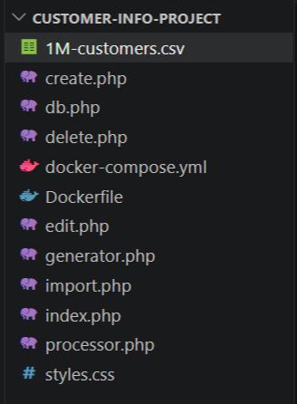
Code
Dockerfile,
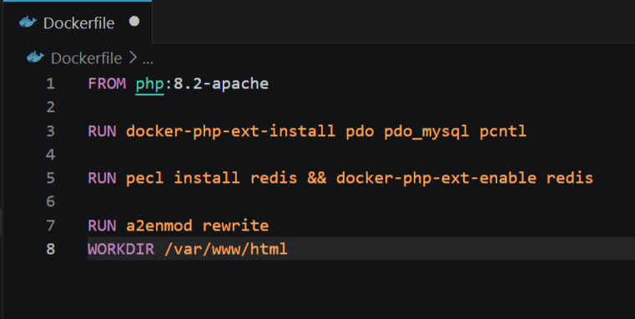

docker-compose.yml
services:
app:
build: .
ports:
- "8080:80"
volumes:
- .:/var/www/html
depends_on:
- db
- redis
networks:
- customer-net

db:
image: mysql:8.0
environment:
MYSQL_ROOT_PASSWORD: root
MYSQL_DATABASE: customer_db
command: --max_allowed_packet=64M
networks:
- customer-net

redis:
image: redis:alpine
networks:
- customer-net

networks:
customer-net:
driver: bridge

Generator.php
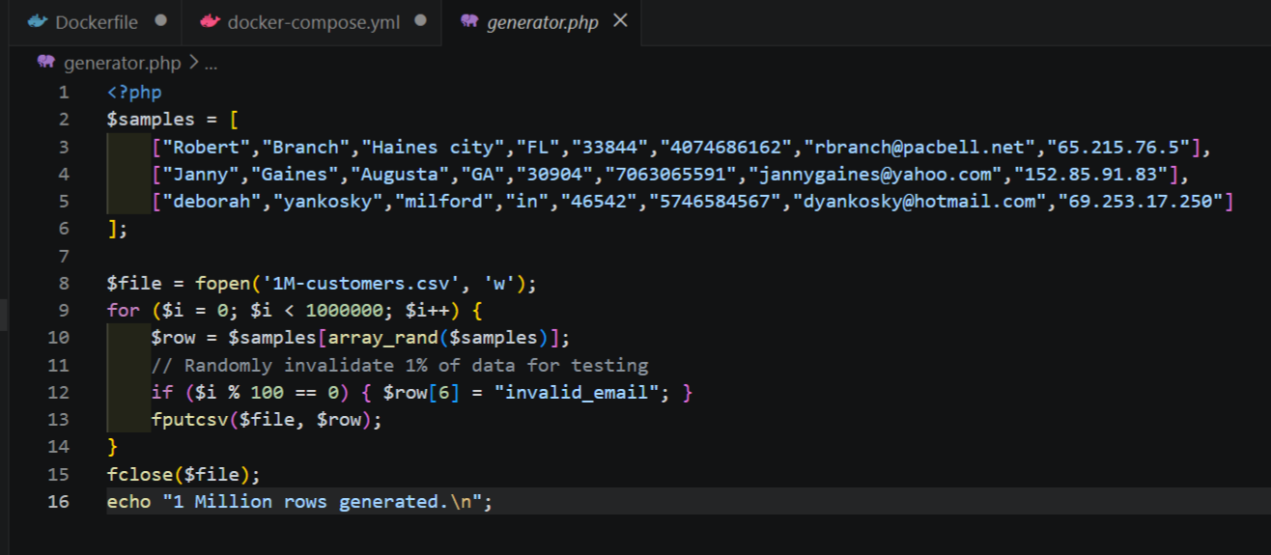

Explanation
This file will create 1M_customer.csv file

Import.php
<?php
require 'db.php';

// 1. Connect to DB and Redis
$pdo = getDBConnection();
$redis = new Redis();
$redis->connect('redis', 6379);

$file = fopen('1M-customers.csv', 'r');
$batchSize = 5000; // Insert in chunks for speed
$count = 0;

echo "Starting import...\n";

$pdo->beginTransaction();

while (($row = fgetcsv($file)) !== FALSE) {
// Basic validation to separate valid/invalid (Requirement #4)
if (filter_var($row[6], FILTER_VALIDATE_EMAIL)) {
$stmt = $pdo->prepare("INSERT INTO valid_customers (first_name, last_name, email, phone, ip) VALUES (?, ?, ?, ?, ?)");
$stmt->execute([$row[0], $row[1], $row[6], $row[5], $row[7]]);
} else {
$stmt = $pdo->prepare("INSERT INTO invalid_customers (first_name, last_name, email, phone, ip, error_message) VALUES (?, ?, ?, ?, ?, ?)");
$stmt->execute([$row[0], $row[1], $row[6], $row[5], $row[7], 'Invalid Email Format']);
}

$count++;

// Commit every 5000 rows to keep memory low
if ($count % $batchSize == 0) {
$pdo->commit();
$pdo->beginTransaction();
echo "Imported $count rows...\n";
}
}

$pdo->commit();
fclose($file);

// 2. CLEAR REDIS so the dashboard updates
$redis->flushAll();

echo "Finished! $count rows processed. Dashboard updated.\n";

Explanation:
This file will insert all the customer information to the database.

Syntex
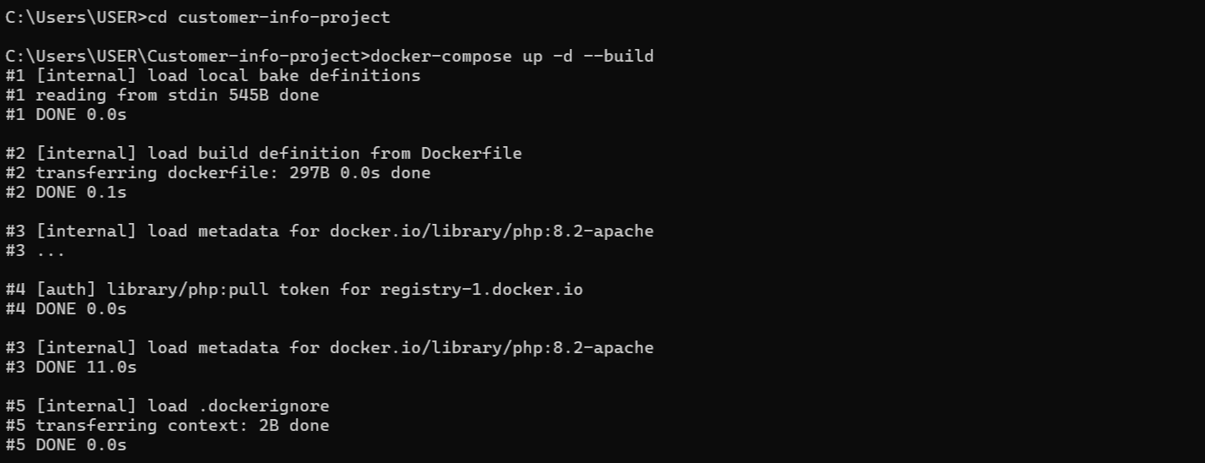

Output:
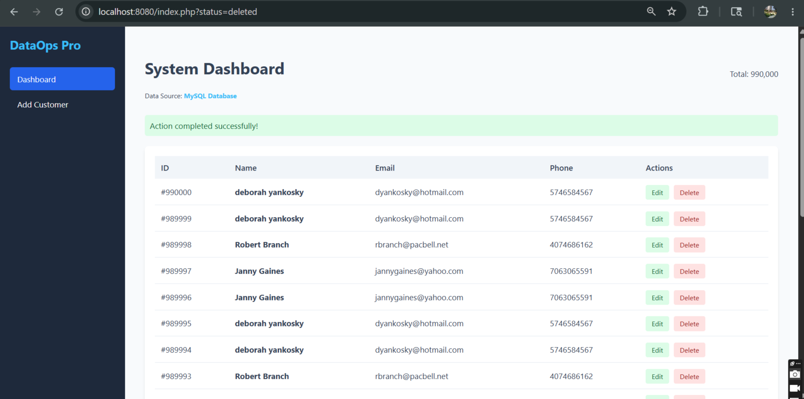

Add
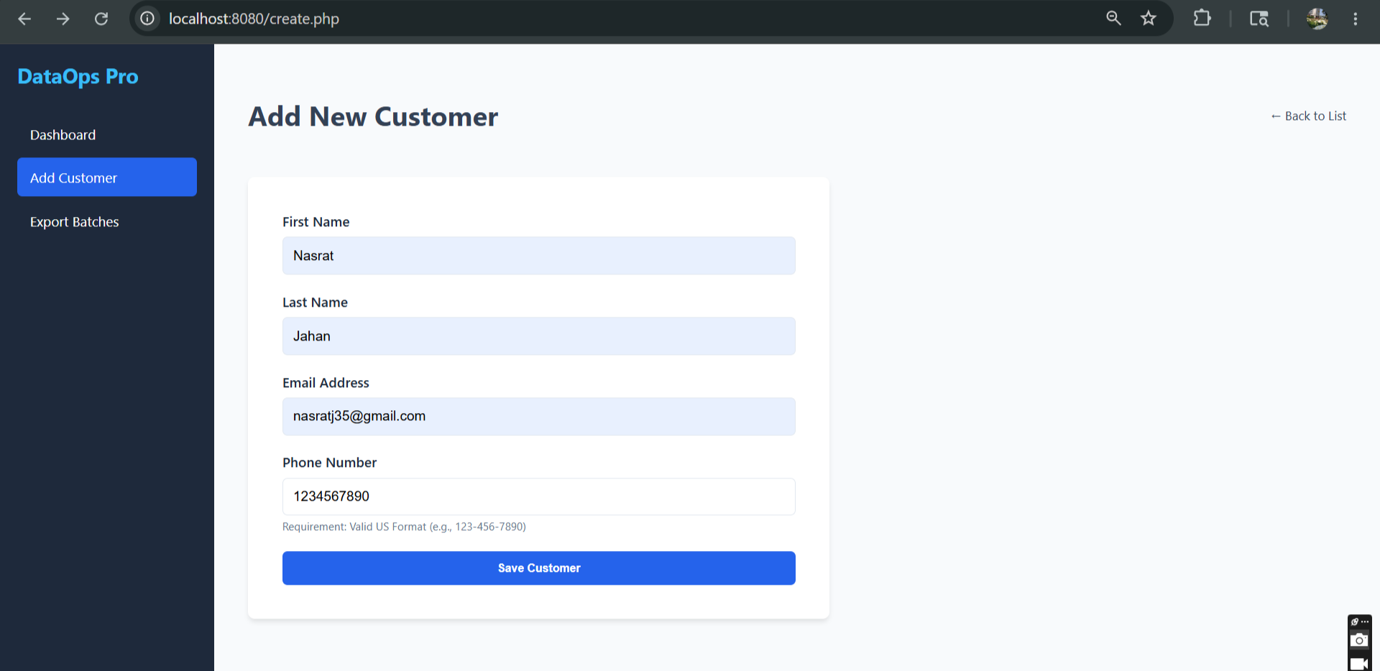
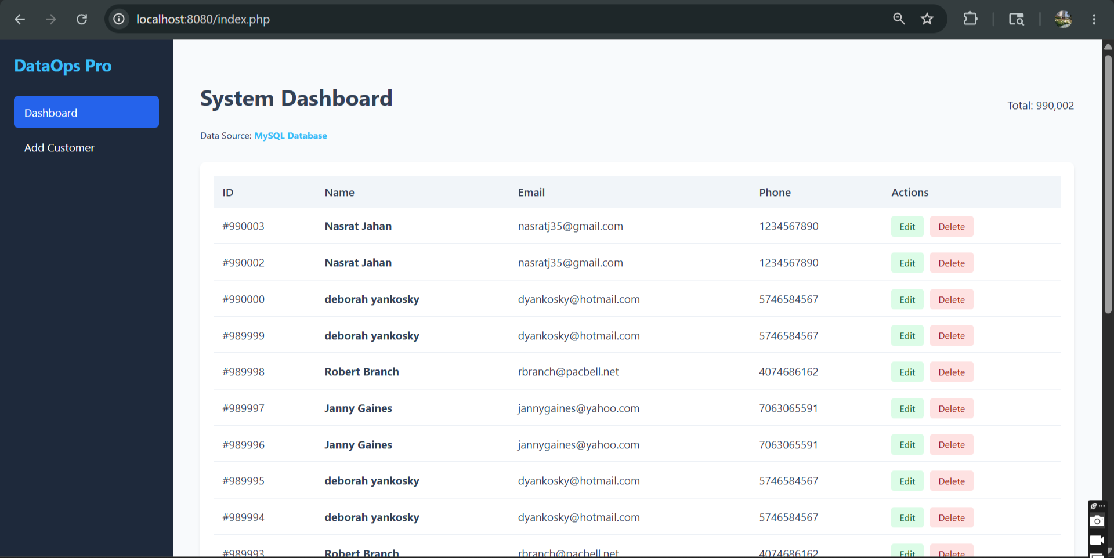

Edit
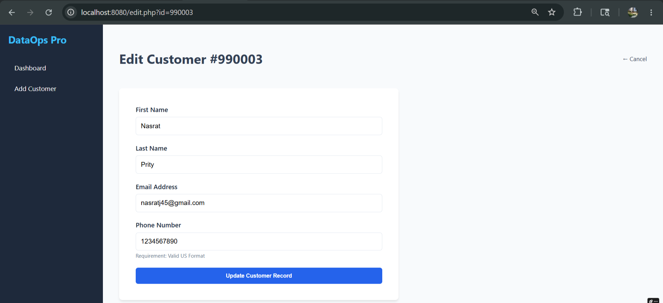
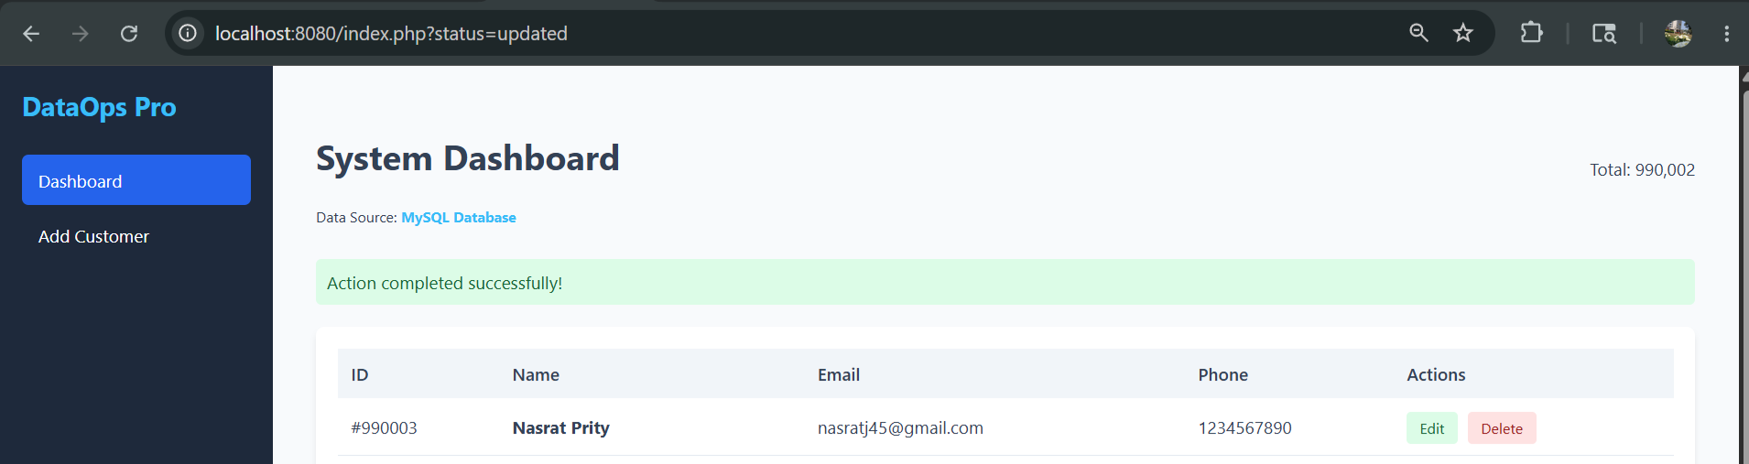

Delete
